

Peer Assessment: Instructor Guide

# Background and scope

This tool provides a workflow for Peer Assessment of group member contributions entirely within Brightspace. It is built for a scenario where each student allocates a pool of points across their group members for each assessment criterion: 100 x *n* (n = number of students in the group). This process could include a self-evaluation depending on the Instructor’s preference at the time of creating the assessment.

Example: For a group of 4, with self-assessment turned on, you have 400 points to assign over the 3 group members and yourself for each assessment criteria. Without self-assessment, this 400 would be 300.

All the peer evaluated scores for each student are converted into a percentage score which can be stored in a grade item and combined with the tutor grade if desired via a formula grade item. This gives the flexibility to make peer assessment worth a percentage of the tutor score, or not, but ultimately allows each student to be given an individual grade for their contribution to the group.

The scenario where students peer *review* each other’s individual work is out of scope.

When looking into literature around peer assessment, main benefits of peer assessment are derived when multiple rounds of it happen throughout the group project, so this tool has been designed to reduce the administrative burden of administering peer assessment to make this more viable.

# Instructor: Set up the Peer Assessment

## Group set up

Before you start, you will need to have set up a group category which defines each of your student groups. This could be an existing group category in Brightspace that is being used to facilitate the group work or group submission of the work. The one stipulation is that you need to ensure that no student is a member of more than one group within that category.

## Peer Assessment set up screen

Use the Peer Assessment link in your course navigation to access the Peer Assessment set up screen. This asks for several pieces of information:

### Activity Name

This name will appear as the name of the Content item which students will use to provide their assessment, and in the grade item through which feedback is provided. You can use “Peer Assessment” but it is better to add something more descriptive to distinguish between multiple rounds of Peer Assessment.

### End Date

The cut off date for the submission of Peer Assessments.

### Group Category

Select the group category you set up previously.

### Assessment Criteria

These are the criteria on which students will be asked to judge their peers. It is advisable to keep these brief; you can expand on them in the instructions to students.

Use the **Add another criterion** button to add extra criteria. If you create extra boxes in error just leave them blank.

### Self Assessment

Indicate if students will assess their own contribution.

### Student comments

Indicate if students are given an opportunity to leave a comment with each of their assessments. You can choose whether to publish these (anonymously) as feedback to the student to whom they refer, with an opportunity to edit them before publication.

### Instructions to students

This text is displayed at the top of the screen inviting students to give their assessment. You can modify the default to suit your purposes.

## Submit the form

Once you click submit, any errors will be highlighted for your attention, otherwise the tool will:

* Create a content item with the name you specified. Students use this to give their assessment and you use it to review their feedback. This will be created in the Assignments module, but you can move it if required.
* Create an assignment. You won’t interact with this directly, but it is used to store the students’ assessments.
* Create a grade item. You can publish students’ peer scores and the edited comments (if you allowed these during setup) to this grade item for students to review and for you to combine with your instructor assigned grade.

It is worth immediately accessing the content item in case any notices are displayed, for example if there are students in multiple groups a warning will be displayed here.

# Student Workflow: Assess your peers

Students give their assessment by accessing the content item created by the set up screen.

This screen looks very different when accessed from a student role.

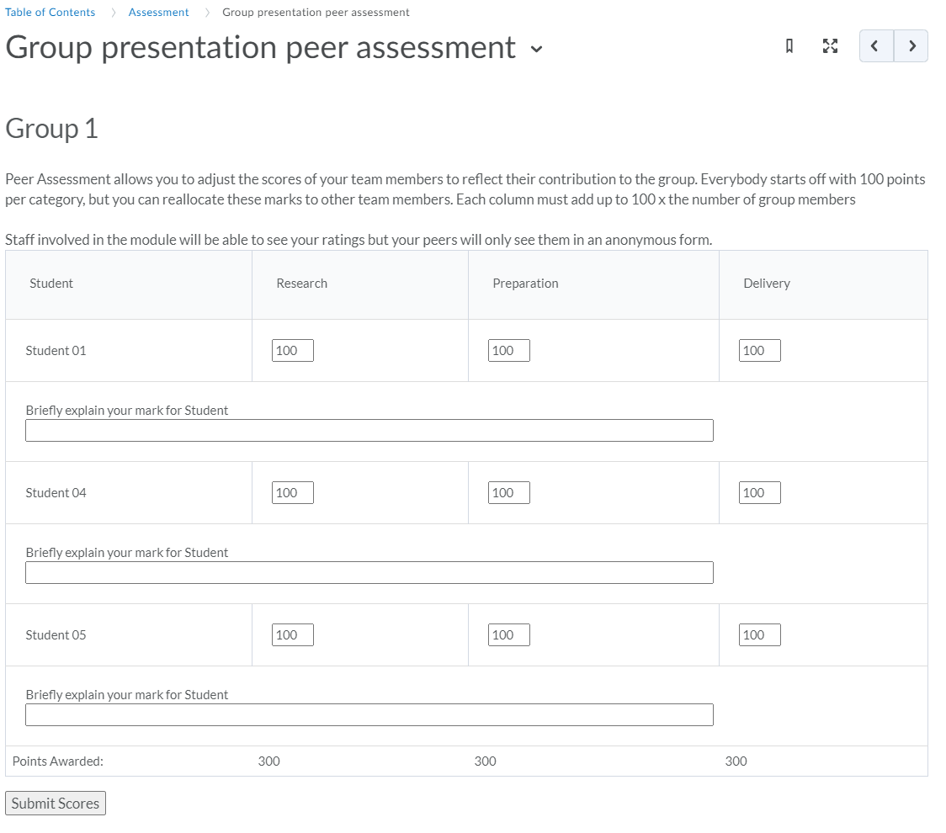

The text displayed at the top of the screen is the instructions, then each column represents the assessment criteria you specified.

The system defaults to a position of each student having 100% for each criterion. Students can modify these scores to reflect how they feel the work was distributed and each student contributed.

The last row of the table shows the sum of the marks awarded. If these do not add up to the required 100 x n members of group this is highlighted and the Submit Scores button is removed until the marks add up correctly.

When the student clicks Submit Scores, their marks and comments are submitted in code form to the peer assessment assignment. They will not receive an email receipt for this submission.

If a student who has already submitted their assessment attempts to access the content item they will be shown a notice reminding them that they have already completed this assessment.

# Instructor: Review & Publish assessments

When accessed with an account enrolled in the course with a non-student role, the content item will show you the peer reviews from each student and allow you to publish the grades.

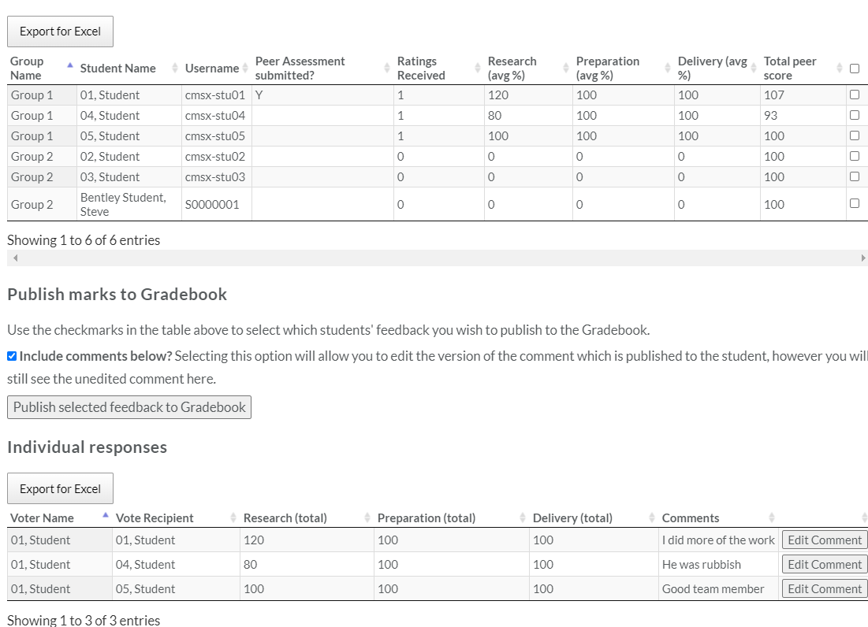

The screen is split into 2 sections:

* The top table in the screen gives a summary of each student’s calculated score, with an option to download it as a CSV file for use in Excel.
* The bottom table in the screen shows the Individual Responses section allows you to review each of the individual ratings received, and again these are downloadable.

## Publishing marks

Use the checkbox next to each student’s name in the top table of the screen to select which marks you wish to publish to the Gradebook. The checkbox in the table header is a select all button. Where a grade has already been published for a particular student, the checkbox is replaced with an icon indicating that it is not possible to write a score for this student.

Clicking the **Publish selected feedback to Gradebook** button will transfer the final percentage score into the grade item, with the category scores added to a comment on the grade item. (To see these in the Grade Tool, select Enter Grades from the column header in Spreadsheet view).

You can choose to include the comments which each student received. These are attached to the grade comments anonymously so they don’t identify the author. Enabling this option reveals an “Edit Comment” button next to each comment, allowing you to moderate the comments to remove anything inappropriate.

*Be aware that the amended comments are only saved to the grade item. If you return to this screen, the unedited comment will be displayed.*

When each mark has been published, the checkbox in the top table changes to indicate this.

*Note: it is possible to make the grade item hidden from users before publishing the marks. This will allow you to make any further amendments before revealing the grades to students.*

## Amending student contributions

If a student wishes to change their assessment, or if you feel that they have been unfair and want them to resubmit after some advice, you can do this by deleting their “submission” to the associated assignment. This will have “(Peer Assessment)” appended to the name. You may need to amend the End Date on the content item to allow for resubmission.

## Intelligent Agents

Because students’ assessments are held in an assignment, you can use Intelligent Agent rules to send reminders to students who have not submitted their peer assessment.